

**AUTOMATIC TENS MACHINE**

**REPORT BY:**

BUSHRA SHAIK (22ECB0B12)

SHIPRA (22ECB0B13)

AFRA FIRDOUSE (22ECB0F16)

**PROFESSOR:** DR RAVI KUMAR JATOTH

**COURSE:** EC236

**DATE:** 12-05-2024

**ACKNOWLEDGEMENT**

As we finalize this thesis, we are deeply grateful for the support and contributions of several individuals who have significantly impacted our research.

We extend our deepest appreciation to our professor Dr. J. Ravi Kumar for his exceptional guidance and unwavering support throughout this project. Sir’s profound expertise, steadfast mentorship, and unwavering encouragement have been instrumental in shaping the trajectory of our project on Transcutaneous Electrical Nerve Stimulation (TENS). His dedication to our academic and professional development has been a constant source of inspiration, driving us to pursue excellence in every aspect of our work.

His insightful feedback, invaluable insights, and tireless commitment have significantly enriched our understanding of TENS and its therapeutic applications. His profound impact on this project cannot be overstated, and we are profoundly grateful for the privilege of working under his guidance.

We express our sincere gratitude to Dr. J. Ravi Kumar for his unwavering support, guidance, and mentorship, which have been pivotal in our academic journey.

**CERTIFICATE OF COMPLETION:**



This certifies that Bushra Shaik (22ECB0B12), Shipra (22ECB0B13) and Afra Firdouse (22ECB0F16) completed the laboratory project on “TENS PULSER” conducted at the National Institute of Technology, Warangal under the guidance of Dr. Jatoth Ravi Kumar on May 11, 2024.

This certificate is awarded in recognition of the student's dedication, hard work and successful participation in laboratory experiments. We acknowledge their commitment to academic excellence and the successful completion of prescribed laboratory requirements.

Signature of Professor

**TABLE OF CONTENTS**

* **ABSTRACT**
* **INTRODUCTION**
* **HARDWARE USED**
* **EXPENDITURE ON PROJECT**
* **PROJECT WORKING**
* **MODEL WAVEFORMS**
* **PROTEUS SIMULATIONS**
* **BREADBOARD WORKING**
* **STRIP ON BOARD CIRCUIT WORKING**
* **APPLICATIONS**
* **CONCLUSION**

**ABSTRACT**

Transcutaneous Electrical Nerve Stimulation or TENS is an electrotherapeutical process of using electrical current to excite and stimulate the nervous system of a living body. The term ‘electrotherapy’ has been applied to a variety of treatments including the use of machines such as deep brain stimulators for neural diseases, shock therapy, etc. This term has also been applied focussing on the use of electrical current to speed up the process of wound healing.

Utilizing 555 IC timers in both astable and monostable configurations, these timers enable the precise modulation of electrical signals, enhancing the efficacy and control of pain relief applications.

This report documents the design, operation and construction of such a system which can be used to treat ailments at a very low cost and can also be switched by the user from a low-frequency system to a high-frequency system for desired application.

**INTRODUCTION**

The Transcutaneous Electrical Nerve Stimulation (TENS) Machine is a portable device designed to alleviate acute and chronic pain by stimulating the peripheral nervous system through controlled electrical currents. Its mechanism involves electrodes placed on the skin's surface, delivering adjustable electrical impulses to targeted areas.

TENS machines offer customizable settings, including pulse width, frequency, and intensity. Frequency options range from low (<10 Hz) to high (>50 Hz), with low frequencies typically used for motor effects and high frequencies for sensory responses. Intensity adjustments allow users to achieve either sensory (comfortable sensation without muscle contraction) or motor (muscle contraction without pain) effects.

Research suggests TENS operates by modulating pain signals at both peripheral and central levels. Low-frequency TENS activates μ-opioid receptors, promoting the release of endorphins and increasing local blood flow to relieve pain. In contrast, high-frequency TENS activates δ-opioid receptors, further blocking pain signals from reaching the brain.

Functional MRI studies have demonstrated TENS's ability to reduce pain-related cortical activations. High-frequency TENS has shown efficacy in conditions such as carpal tunnel syndrome, while low-frequency TENS has been effective in reducing shoulder impingement pain and modulating pain-induced brain activation.

The TENS device described in the paper utilizes a 555 timer to generate square waves. Square waves are preferred for their efficient penetration into the body at any given frequency output, making them ideal for frequency-generating devices like TENS machines.

**COMPONENTS USED**

|  |  |  |
| --- | --- | --- |
| **COMPONENT** | **QUANTITY** | **COST** |
| IC555 | 4 | 24 Rs |
| IC7486 | 1 | 20 Rs |
| 1000Uf Capacitor | 2 | 2 Rs |
| 1uF Capacitor | 2 | 2 Rs |
| 10K Resistor | 5 | 2.5 Rs |
| 2.2K Resistor | 1 | 0.5 Rs |
| 1K Resistor | 6 | 3 Rs |
| LED | 4 | 4 Rs |
| BUZZER | 1 | 40 Rs |
| PUSH BUTTON | 2 | 40 Rs |
| TRANSORMER | 2 | 340 Rs |
| CONNECTING WIRES | 50 | 30 Rs |
| SOLDERING WIRE + FLUX | 1 | 60 Rs |
| SOLDERING IRON | 1 | 180 Rs |
| IC7809, IC7809, 1C7812 | 1 | 60 Rs |

**TOTAL COST: 808 Rs**

**IC 555 PIN DIAGRAM**

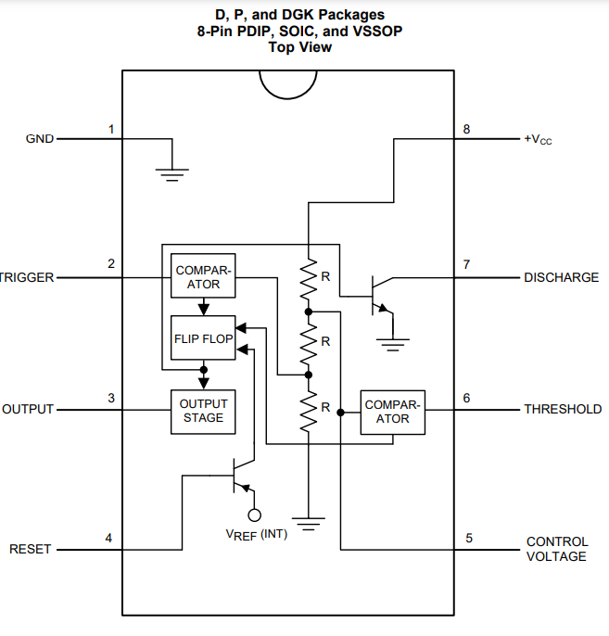

**ELECTRICAL CHARACTERISTICS:**

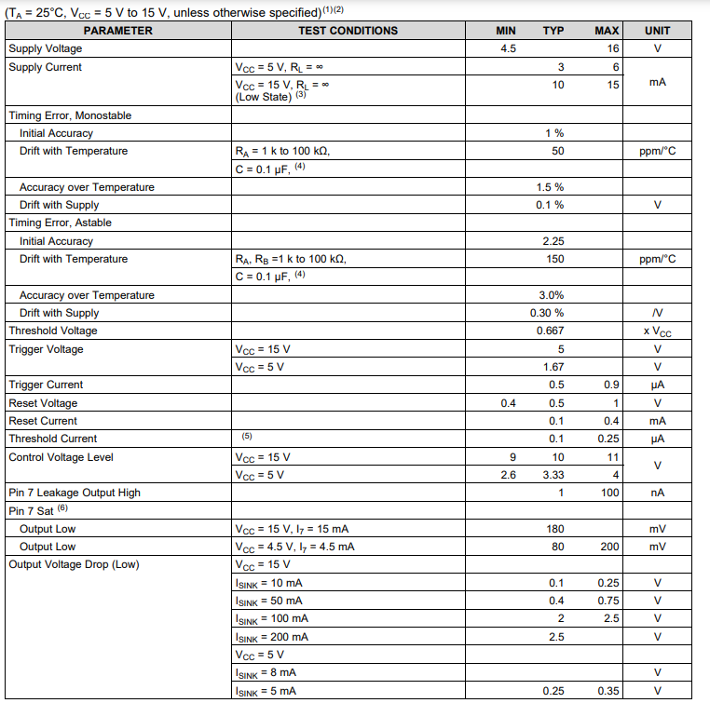

**SN74HC86 Quadruple 2-Input XOR Gates**

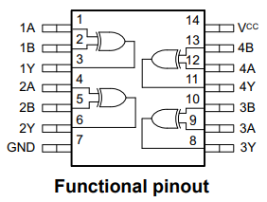

**ELECTRICAL CHARACTERISTICS:**

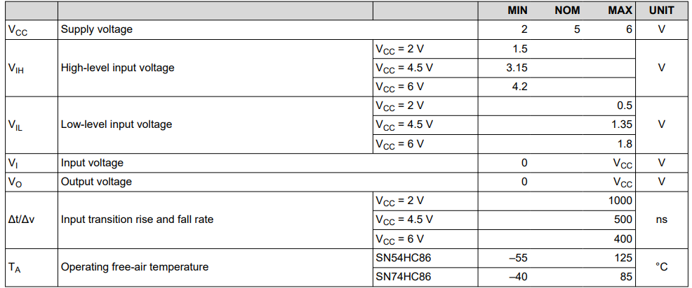

**PROJECT WORKING:**

In this project, two 555 IC timers are employed—one operating in monostable mode and the other in astable mode.

In astable mode, the timer generates a continuous square wave output, with the duty cycle determined by the values of the resistors and capacitors connected to it. The astable timer oscillates between charging and discharging states, resulting in a waveform with a specific frequency and duty cycle. The duty cycle obtained in this project was 84.7%, indicating that the output remains high for 84.7% of the total cycle time.

On the other hand, the monostable mode generates a single output pulse in response to a trigger input. The duration of the pulse is determined by the values of the resistor and capacitor connected to it, resulting in a specific pulse width and duty cycle. In this project, the monostable timer produced a 15.3% duty cycle output pulse.

The output of the astable mode is connected as a negative trigger input to the monostable mode. The output of the monostable mode, which is at 9V, is then fed into a centre-tapped step-down transformer rated at 12-0-12 500 mA. The transformer increases the voltage level, yielding an output of 90V.

The resulting waveform, measured using an oscilloscope, displayed a frequency of 100 Hz and an output voltage of 90V.

To automate the on-and-off functionality, an additional circuit with two 555 timers operating in monostable mode was integrated. When power is supplied, triggering the TENS pulser circuit also activates the delay timer buzzer circuit. However, since both circuits' outputs are connected to an XOR gate, which produces an output only when the inputs are different, the buzzer remains silent while both circuits are active. Upon deactivation of the TENS circuit, the timer circuit continues to operate, resulting in a different input to the XOR gate and triggering the buzzer to notify the user of the circuit's shutdown. This setup effectively ensures user notification of the circuit's operational status.

**MONOSTABLE MODE OPERATION:**

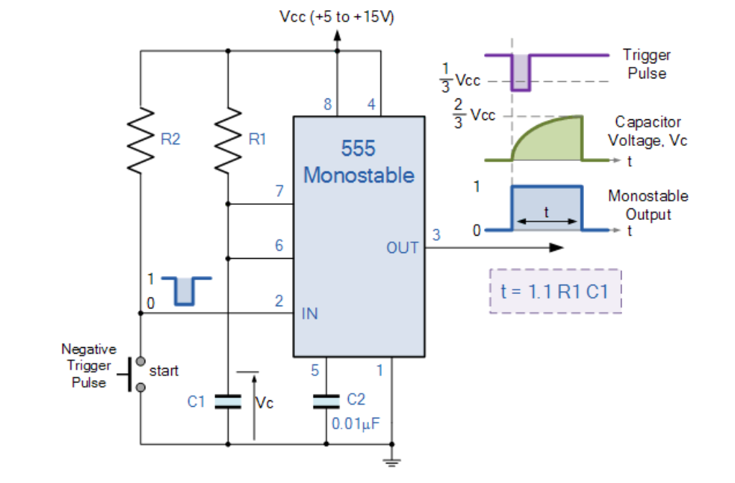

**ASTABLE MODE OPERATION:**

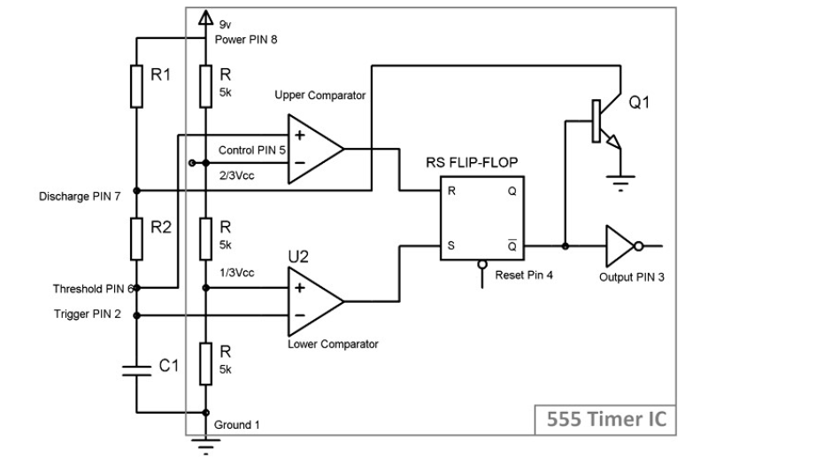

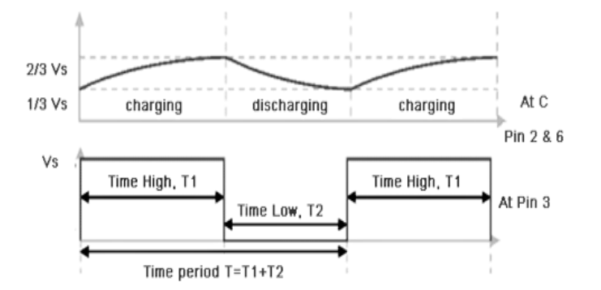

**FORMULAE USED FOR ASTABLE MODE:**

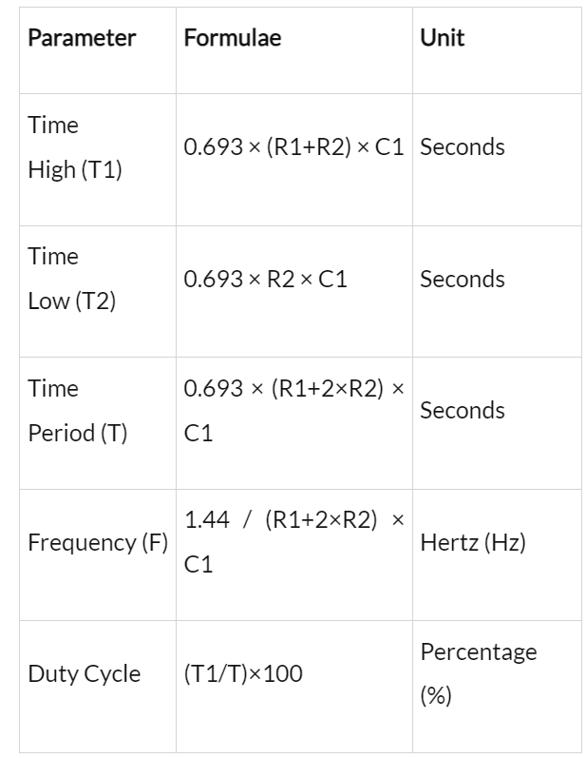

**CIRCUIT DIAGRAM**

**TENS PULSER**

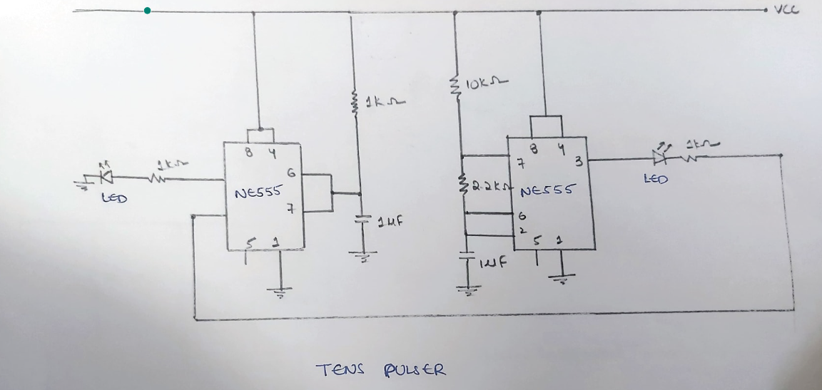

**BUZZER INTEGRATED SYSTEM**

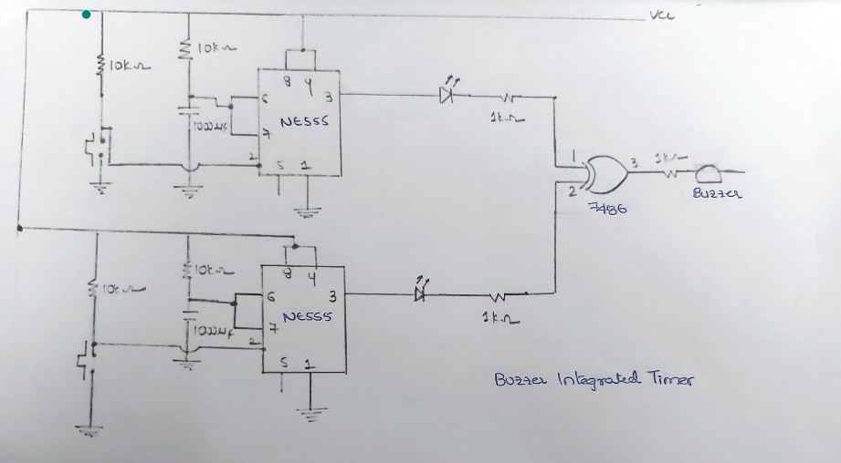

**VARIABLE VOLTAGE REGULATOR CIRCUIT:**

**(USED FOR POWER SUPPLY)**

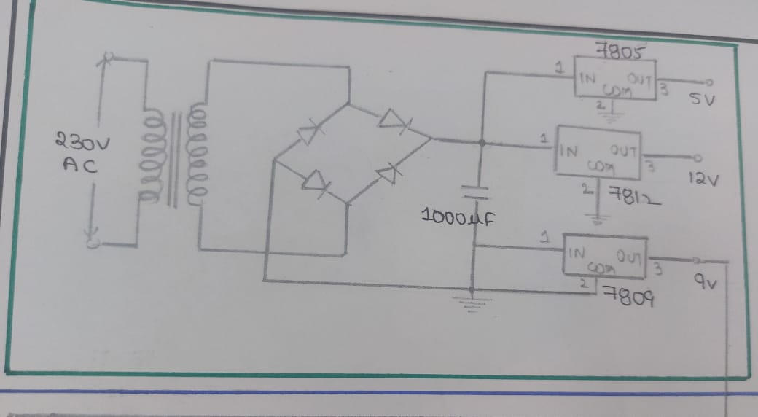

A fixed voltage produces a fixed DC output voltage, which is either positive or negative.

* 78XX produces positive voltages.
* 79XX produces negative voltages.

We used 7809 IC to produce a constant 9V voltage.

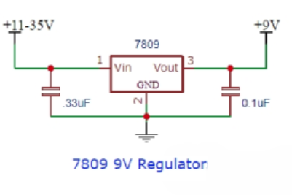

**PROTEUS CIRCUIT:**

**INTEGRATED BUZZER SYSTEM CIRCUIT**

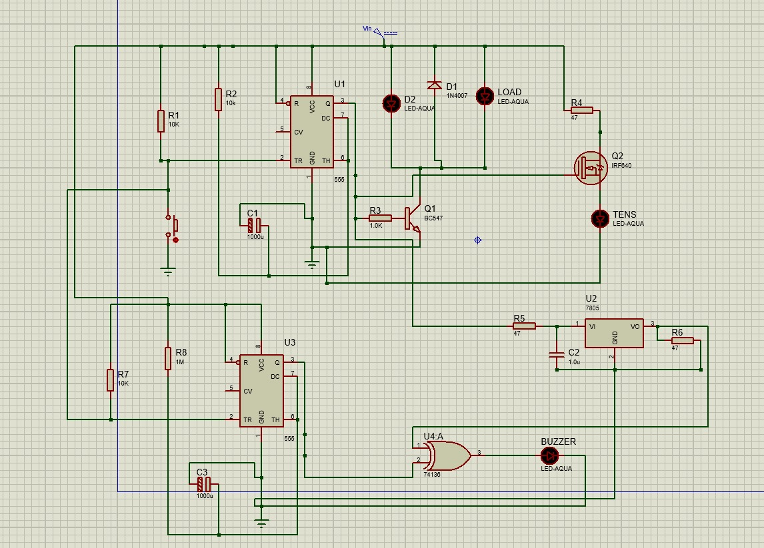

**TENS CIRCUIT**

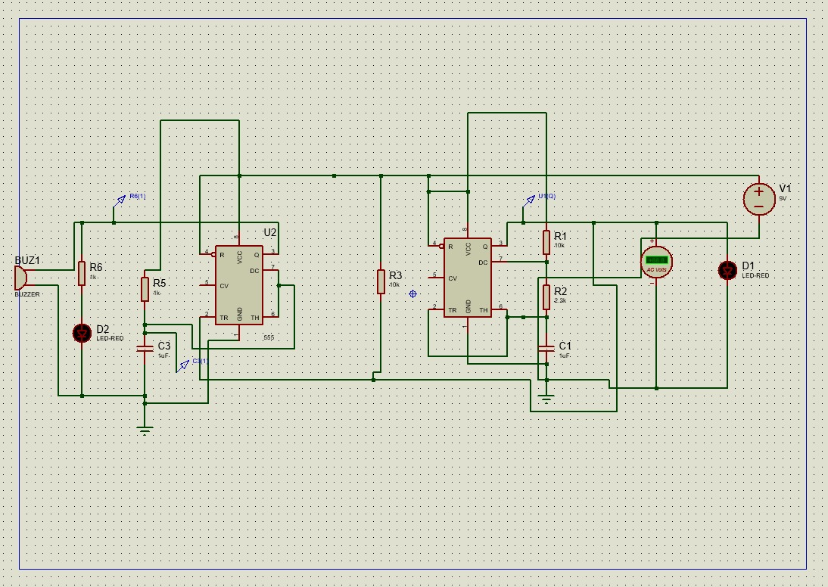

**INTEGRATED BUZZER & TENS CIRCUIT**

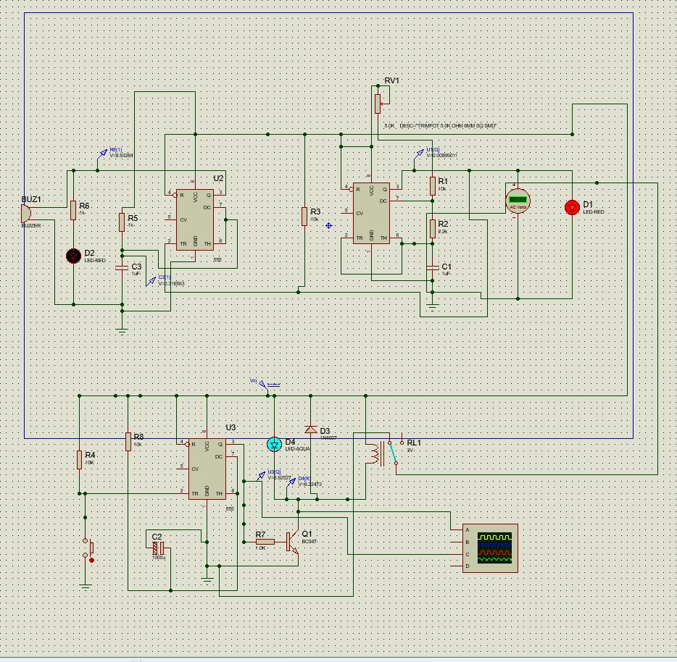

**SIMULATION OUTPUT**

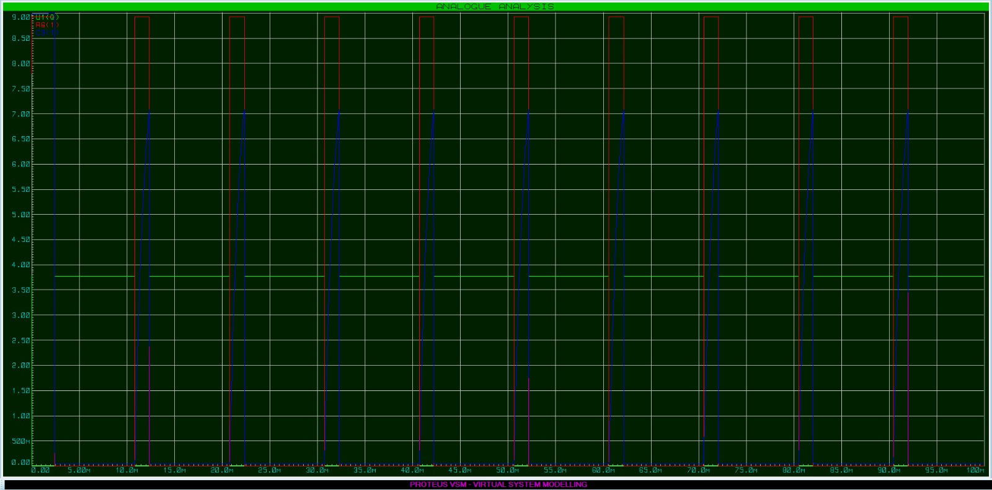

**OUTPUT ON OSCILLOSCOPE**

**WITHOUT TRANSFORMER AT OUTPUT**

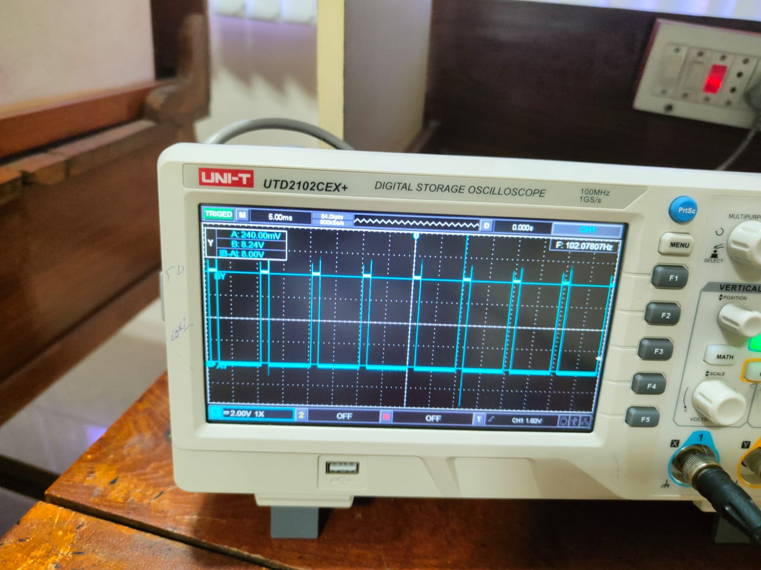

**OUTPUT ON OSCILLOSCOPE**

**WITHOUT TRANSFORMER AT OUTPUT**

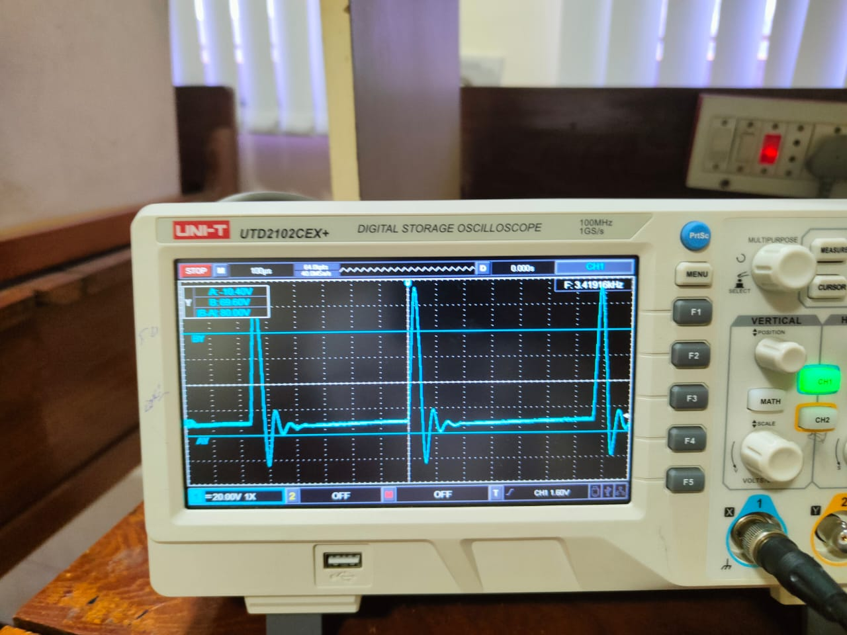

**STRIP ON BOARD WORKING:**

**TENS CIRCUIT**

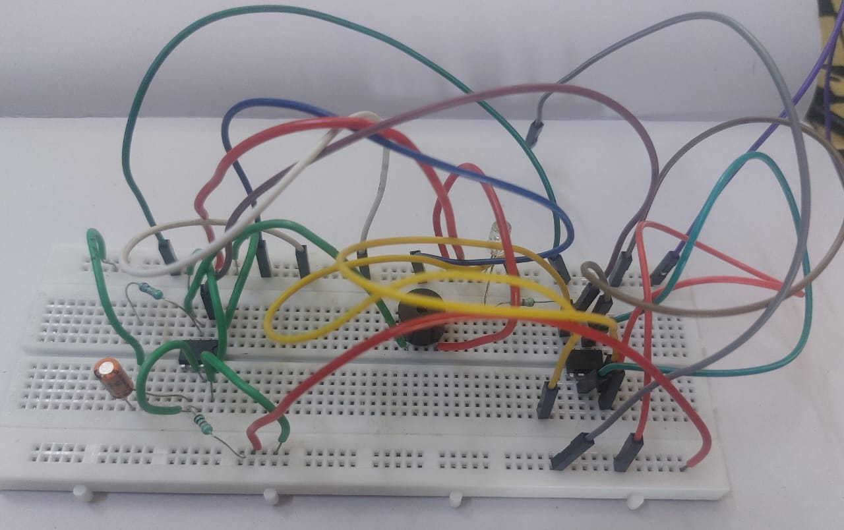

**INTEGRATED TIMER CIRCUIT**

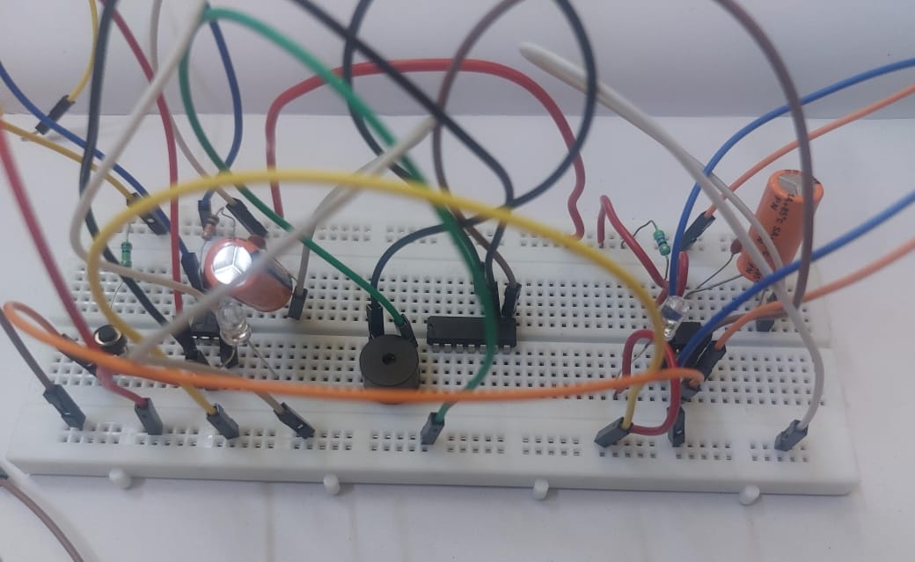

**TENS CIRCUIT**

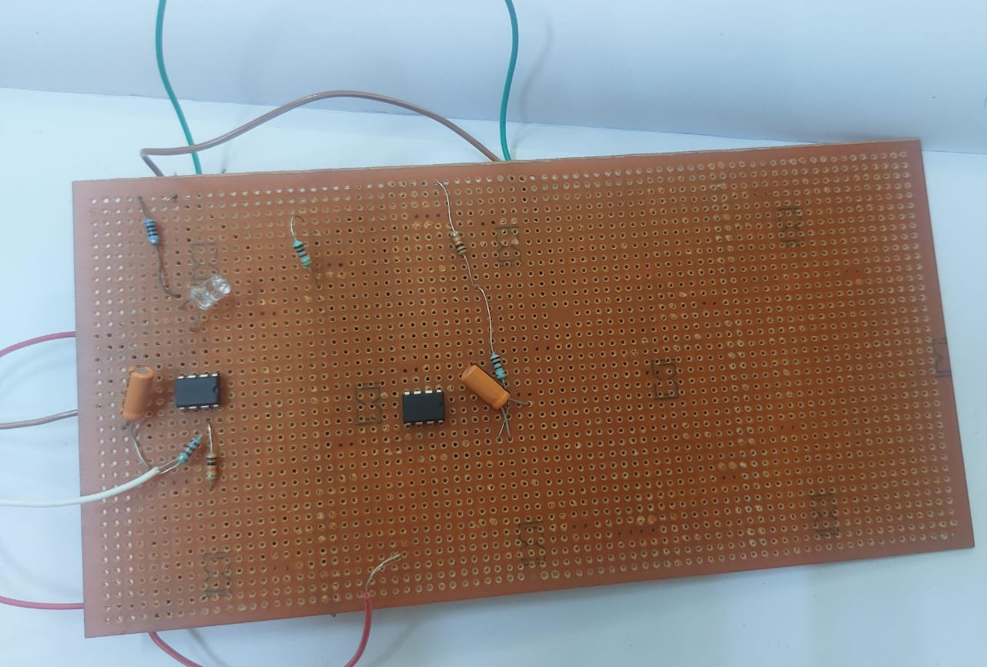

**APPLICATIONS:**

* **Site of Application:** Typically, electrodes are placed near the site of injury, but effectiveness may extend beyond the immediate area due to the potential activation of central mechanisms by TENS.
* **Endorphin Release:** Low-frequency TENS stimulates the body to produce endorphins, natural pain-relieving chemicals akin to morphine, which are neurotransmitters that transmit electrical signals within the nervous system.
* **Personal Control and Usage:** TENS machines can be personally controlled without the need for medical supervision. Usage typically involves 15-20 minute sessions several times a day. They are commonly employed for pain reduction in muscular trauma, joint and nerve pain, and musculoskeletal issues.
* **Effectiveness and Side Effects:** TENS machines are often more effective for specific types of pain, such as muscular trauma and joint pain, compared to abdominal, pectoral, or head pains. They generally have minimal side effects, but caution is advised for pregnant individuals, those with an artificial pacemaker, or a history of epileptic seizures.
* **Combination Therapy:** TENS therapy can be used alone or combined with other professional treatments to enhance pain relief. It may reduce reliance on painkillers, which can have numerous side effects.

**CONCLUSION:**

In conclusion, studies have demonstrated the effectiveness of TENS in reducing pain and associated symptoms in various conditions, including chronic constriction injuries and musculoskeletal pain. High-frequency TENS applications have shown promise in reducing mechanical hyperalgesia, while low-frequency stimulation applied to acupuncture points has been effective in reducing thermal hyperalgesia, particularly when delivered contralaterally.

Despite its effectiveness, the controversy surrounding TENS persists due to limitations in study designs and inadequate understanding of its mechanisms and parameters. However, evidence suggests that TENS offers significant improvements in multiple outcome variables beyond pain relief for long-term users.

Overall, TENS remains a valuable therapeutic option, especially for individuals who have not found relief with conventional pain management methods. Continued research into TENS devices, their theories, mechanisms, and optimal parameters is warranted to further elucidate their efficacy and broaden their applicability in pain management.

**REFERENCE LINKS:**

https://www.ijsr.net/archive/v5i11/ART20162812.pdf